**GENERAL SEARCH ENGINES**

1. **Instya**

**History**

Instya was founded in Mississauga, Ontario, Canada, with the mission to simplify the online shopping experience for both businesses and individual consumers. Recognizing the challenges shoppers face in navigating the vast sea of eCommerce products and websites, Instya was developed to be a powerful tool that helps users make well-informed purchasing decisions. By curating product guides and offering alternative eCommerce platforms, Instya aims to optimize the product discovery process.

**Description**

Instya is an innovative eCommerce product research platform based in Mississauga, Ontario, Canada. Designed to assist both businesses and individual consumers, Instya helps users quickly discover the best products and services online. With its detailed product guides, curated lists, and alternative eCommerce options, Instya serves as a one-stop shop for all your product research needs. Whether you're a consumer looking for specific products or a business searching for reliable suppliers, Instya simplifies the decision-making process.

**What the Tool Is About**

Instya offers two key functionalities:

1. Product Discovery & Buying Guides: The platform features in-depth product research and buying guides, allowing users to compare options, read expert recommendations, and find exactly what they're looking for without wasting time.
2. eCommerce Site Alternatives: Instya allows users to explore alternatives to popular eCommerce platforms like Amazon, eBay, and Walmart, providing a broader range of product options and fresh shopping experiences.

**POC Images**

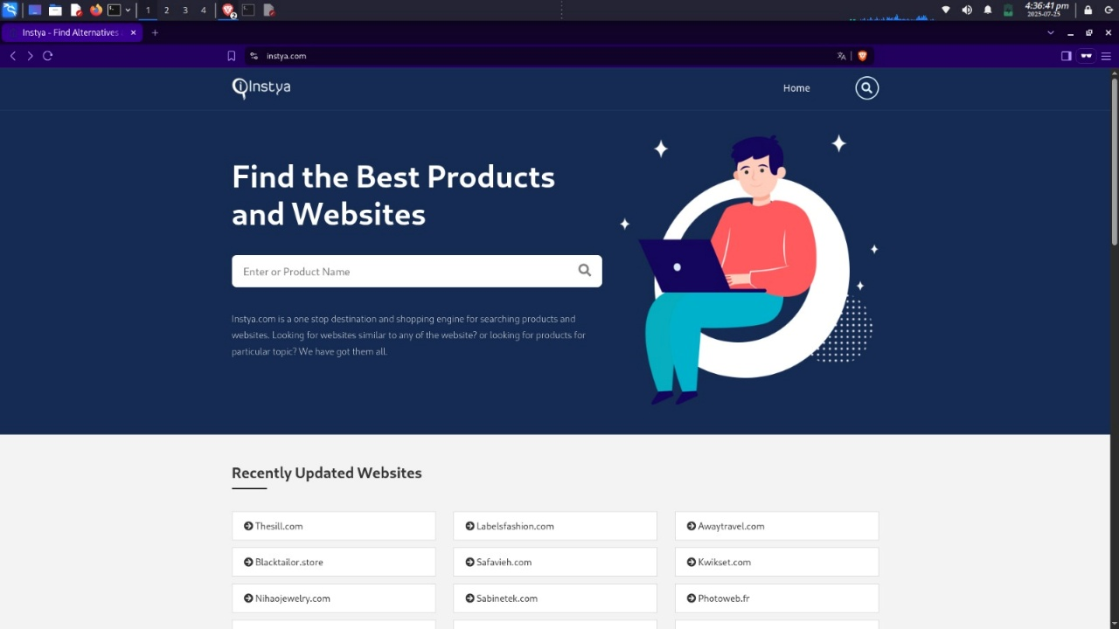

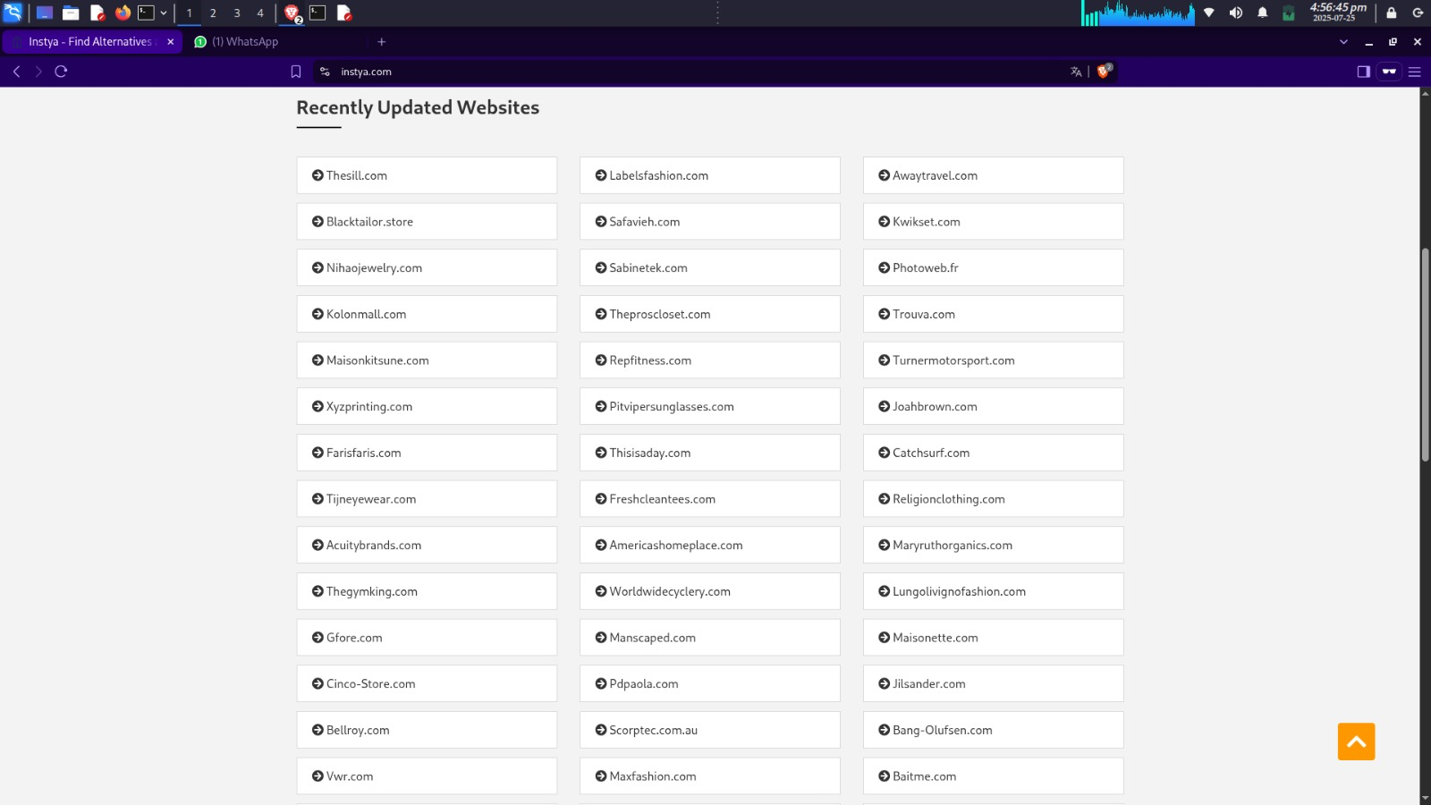

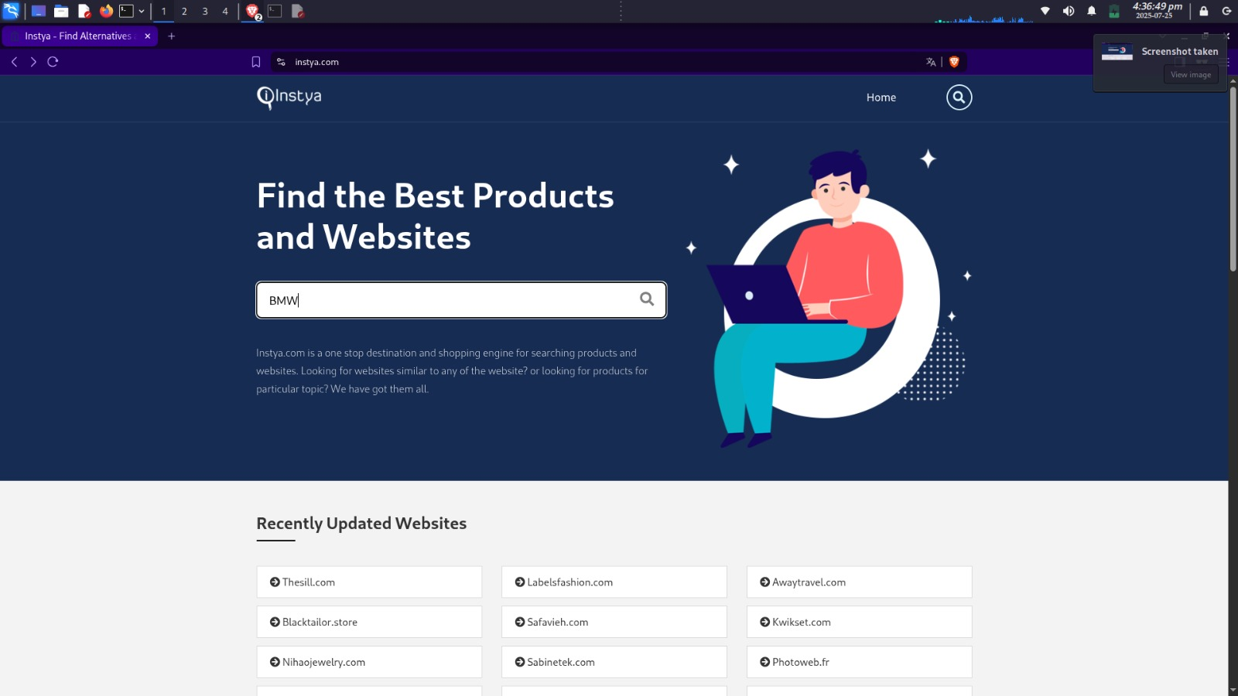

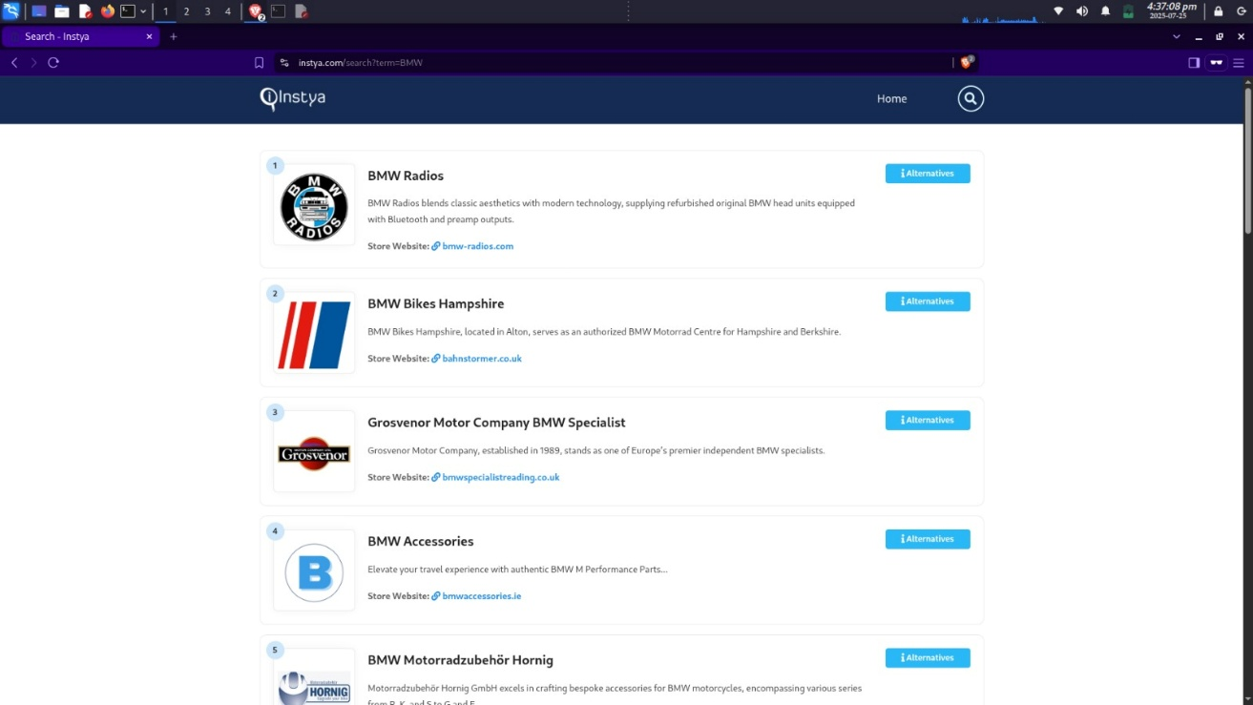

**Key Characteristics**

1. Curated Product Lists: Filtered and well-organized lists across a wide range of categories.
2. Detailed Buying Guides: Expertly crafted guides that help simplify your buying decisions.
3. eCommerce Alternatives: A vast collection of alternatives to major online marketplaces.
4. Product Comparison Tools: Key metrics and data points to help you make informed decisions.
5. Time-Saving Filters: Quick sorting and filtering features that narrow down product choices instantly.
6. User-Centric Interface: Easy to navigate, whether you’re a business or individual shopper.

**Summary**

Instya is a product research platform based in Mississauga, Ontario, Canada, designed to make online shopping simpler for businesses and individuals. With millions of products scattered across thousands of categories, Instya helps users cut through the noise by offering well-researched buying guides and curated product lists. These guides, combined with an easy-to-use search engine, allow users to compare products and make confident purchasing decisions. Additionally, Instya offers an extensive database of eCommerce alternatives, enabling shoppers to discover fresh platforms beyond popular websites like Amazon, eBay, and Walmart. By providing expert insights, product data, and tailored recommendations, Instya ensures users spend less time searching and more time enjoying their purchases. Whether you're looking for the latest gadgets, fashion trends, or niche items, Instya is your ultimate guide to the best products on the market.

1. **Impersonal.me**

**History**

Impersonal.me is a powerful tool designed to perform localized Google searches without requiring a VPN or altering your physical location. By simulating searches with specific country and language parameters, it enables you to view search results from various global regions, providing insights into how different users experience Google searches around the world. The tool was created by Dannie Patiño Hansen.

**Description**

This tool is ideal for SEO specialists, digital marketers, content creators, e-commerce businesses, researchers, and localization experts who need a better understanding of how search results vary across different countries and languages. It provides an efficient way to track global keyword rankings, analyze localized content visibility, and optimize strategies for international markets.

**What is the Tool About?**

Impersonal.me allows users to simulate searches from over 70 countries and 40+ languages without physically being in those locations. This enables businesses and content creators to investigate how their content appears in specific regions, track keyword rankings, and understand global search behavior. It also helps e-commerce retailers optimize product listings and pricing across different markets.

**POC Images**

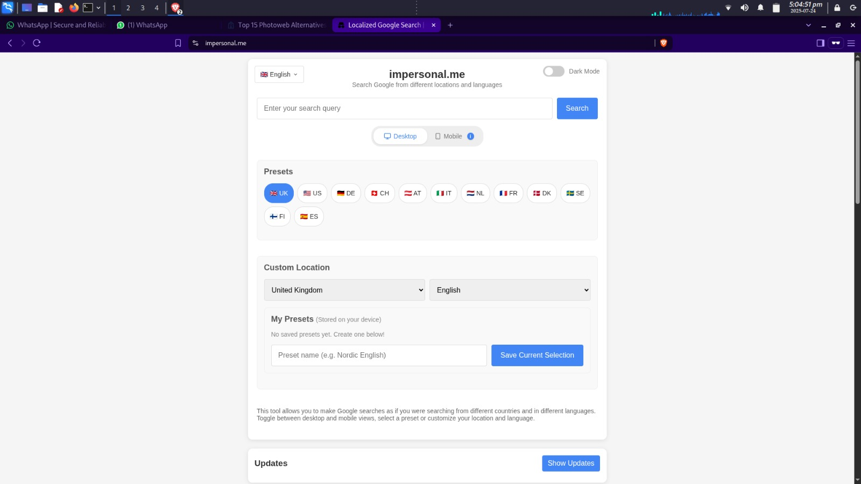

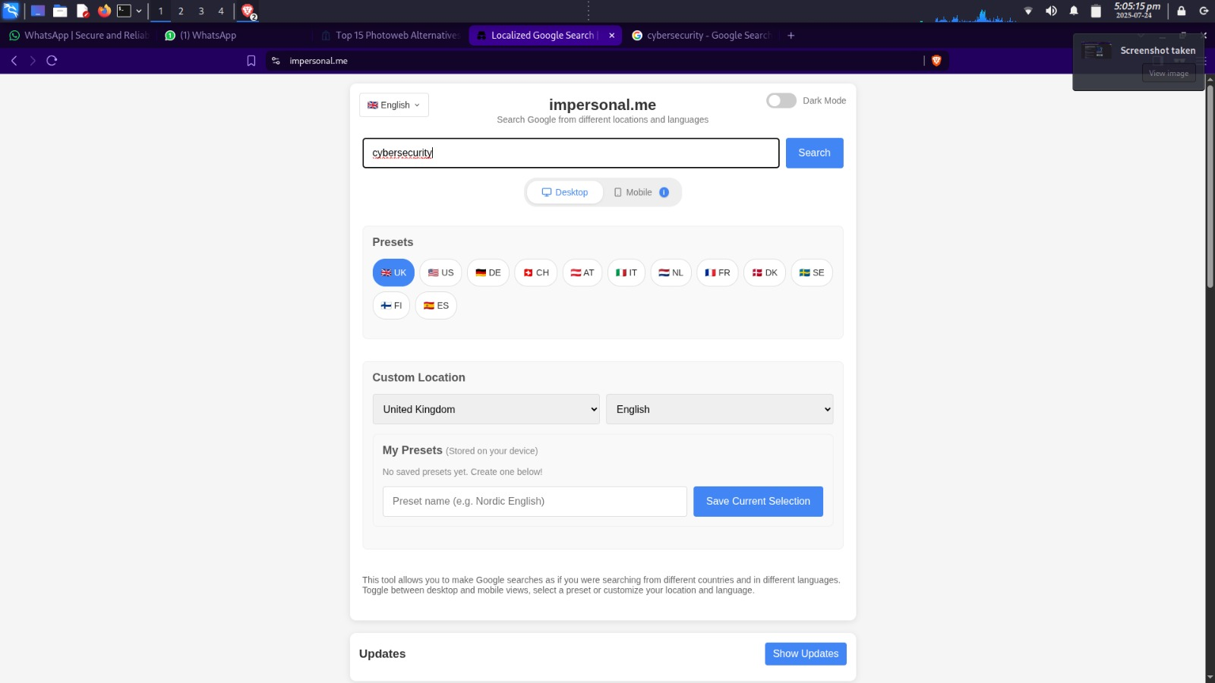



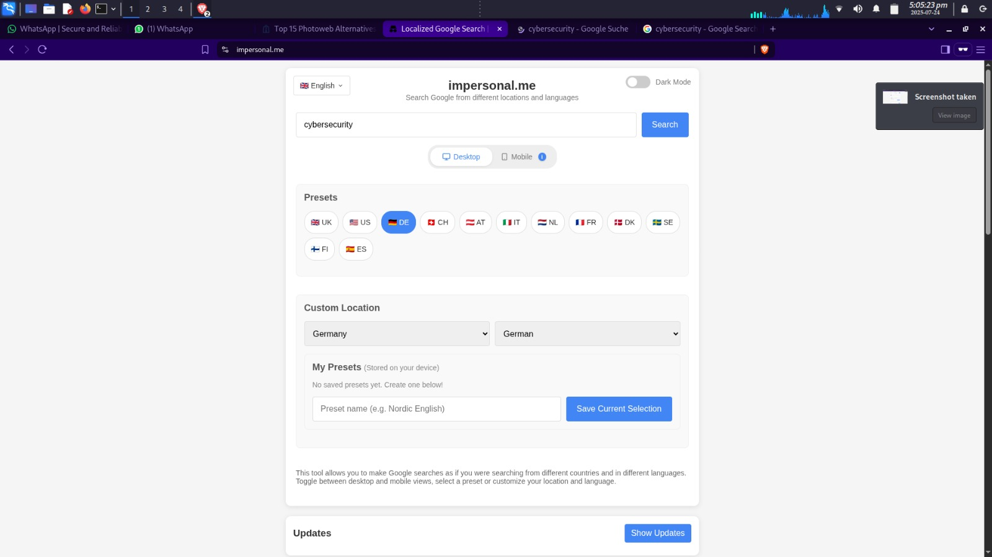



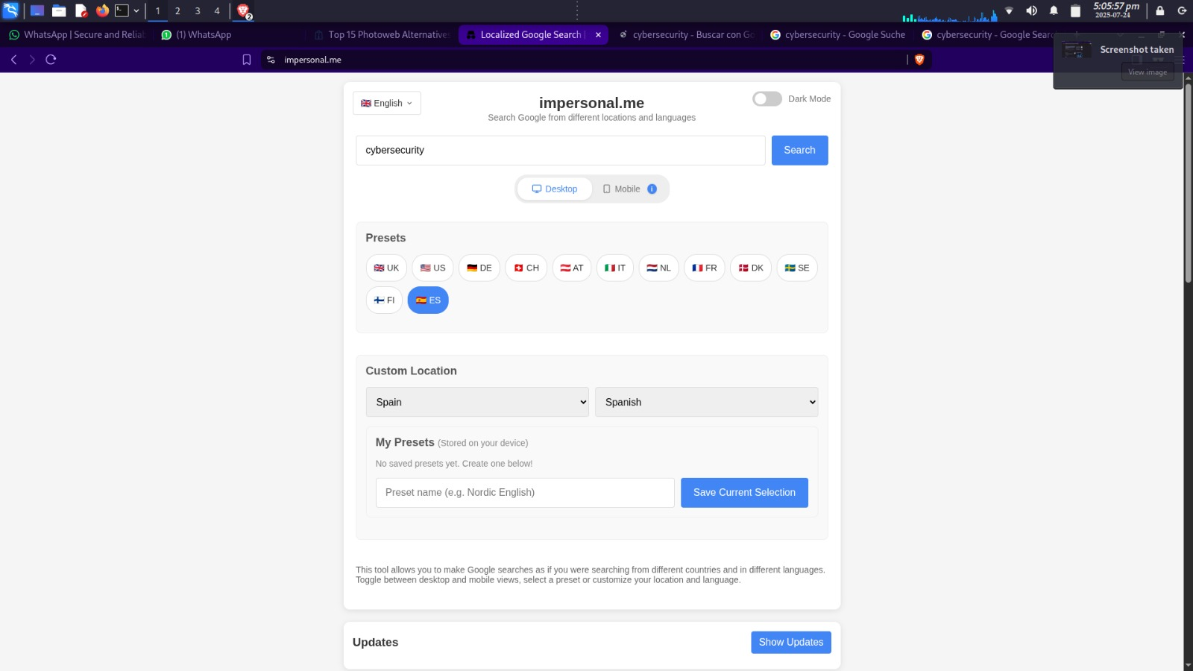



**Key Characteristics**

1. Device Emulation: Toggle between desktop and mobile views to examine how device type affects international search results.
2. Country-Specific Search: Access Google search results from 70+ countries with location and language customization.
3. Multilingual Capabilities: Perform searches in over 40 languages, ensuring a global approach to SEO research.
4. Quick Location & Custom Presets: Save frequently used location and language combinations for easy access.
5. Privacy-Focused: No search data is stored externally—all queries remain local to your browser for enhanced privacy.

**Summary**

The best time to use Impersonal.me is when you need to track international keyword rankings and assess content visibility across different global markets. SEO specialists and digital marketers can use it to monitor how their content performs in specific regions, making it easier to adjust strategies for different countries and languages. Content creators and publishers can optimize their content for regional search variations, helping them identify content gaps and opportunities to improve search visibility across borders.

For e-commerce retailers, the tool is invaluable for checking product rankings, analyzing competitor pricing, and optimizing international product listings. Researchers can analyze global search patterns, study data accessibility, and understand regional trends in search behavior. Translators and localization experts can ensure content is tailored correctly by verifying region-specific terminology and checking for accurate language-specific search functionality.

Privacy is a key benefit when using Impersonal.me. It ensures that all your search data remains local to your browser, with no server-side storage of your queries. This makes it ideal for those who want to maintain privacy during their investigations. The tool also features device emulation, enabling you to switch between desktop and mobile views to see how device types influence search results in different markets. With this, you can simulate authentic user-agent settings, ensuring a deeper understanding of how search results are impacted by both location and device type.

Whether you're refining your SEO strategy or researching global search behaviors, Impersonal.me provides essential tools for effective, privacy-focused, and localized investigations—created by Dannie Patiño Hansen.